Technical Insight

Manufacturing Benchrest Grade Bullets

A bit of background or context is in order for shooters unfamiliar with benchrest to better understand why these specialized bullets exist. Benchrest is a high power rifle sport, shot off a bench, in which the object is to shoot the smallest groups possible, or to hit the very center of a bull’s-eye. Commonly it is shot at 100 yds, 200 yds, 600 yds or 1000 yds. The rifles are purpose built for competition, and serve no other use other than to shoot small groups or to punch the center dot out of a bull’s-eye.

What is the difference between a benchrest bullet and a mass produced bullet manufactured by companies such as Sierra, Hornady, and Lapua? In short, a benchrest bullet is essentially a custom bullet. It is produced in very small quantities for the express purpose of competition shooting, whereas the bullets you find on the shelf of your local sporting goods store are produced in very large quantities and very few of which will ever be fired in a competition. The actual steps in the manufacturing process are similar, with the common mass produced bullet using automation to its advantage in turning out tens (if not hundreds) of thousands of bullets in a production run.

Readers should take note that there is nothing wrong with the bullets produced by the major manufacturers. They make great bullets. The difference is in the context of their use. In the never-ending evolution of competition benchrest, the game as it is currently played demands perfection in all aspects. This means equipment and shooter! Barrels, scopes, actions, and of course bullets need to be perfect. Uniform weights, dimensions and run-out are required of the bullets. This level of perfection is not normally obtainable in a mass produced environment.

Thus, in the arena of competitive benchrest, the custom bullet has replaced the mass produced bullet.

In order to gain some insight into this manufacturing process, I contacted Dan Opel of Opel Bullets to answer a few questions and explain the process of manufacturing a benchrest grade bullet. Dan is a long time bench shooter and is more than qualified to speak on this topic having been producing benchrest bullets for a number of years now.

Q. Dan, first could you explain what steps are involved in making a jacketed bullet?

A. Rick, at its most basic level, a jacketed bullet is made by seating a lead core inside a copper jacket and then forming the pointed nose of the bullet. It is that simple. There are just two components (jacket and core) and two operations, (core seating and pointing up the jackets).

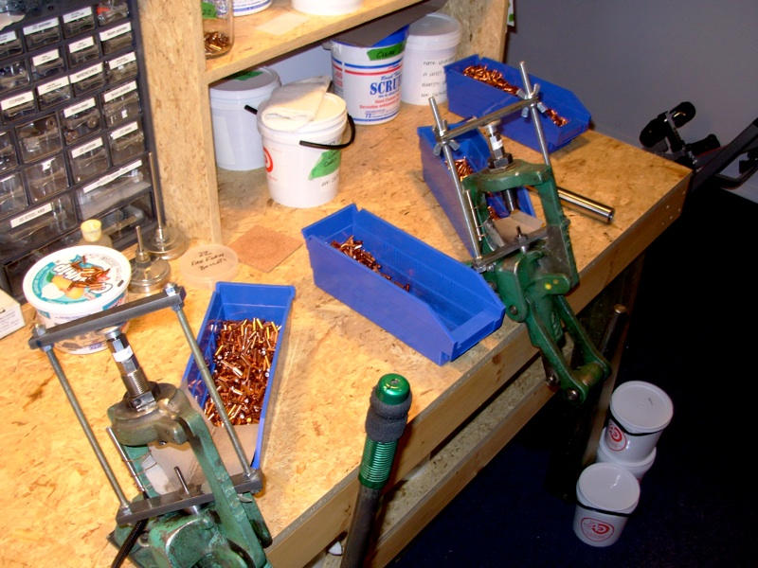
We need to back up a bit and look at what is required before making the bullets. You need to decide on what kind of bullet will be produced. Several choices have to be made such as flat base vs. boat tail, what ogive the bullet will be 6 – 7 – 8, or maybe a double radius ogive, which is in favor now. Then a die set must be ordered to produce this bullet, dies come from several manufacturers and are usually made with a carbide insert for long life. These die sets will run approximately $3500.

The next step is deciding on the bullet weight and ordering the correct jackets. The jackets will need to be of a suitable length to match the desired final weight and be of sufficient length to hold the correct amount of lead for the given weight. There are many different lengths of jackets for each diameter, the longer the jacket, the heavier the bullet can be. As a side note J-4 are the only BR grade jackets available at this time. There have been other suppliers at times, but none that can be counted on for a consistent and high quality supply.

Lets use the 6mm jacket for all examples in this discussion. The most common jacket in use in short range BR is the .825”. This can be used to produce bullets weighing from 65 grains to 68 grains. The other common jacket length is the .790”. which will yield bullets in the range of 62 grains to 68 grains. Once the selected lot of jackets are weighed, then the lead cores can be cut to the appropriate length to give the desired weight of the assembled bullet. In the case of the 66 grain bullet, the respective weights are a 21.3 grain jacket and a 44.7 grain lead core, giving a 66 grain bullet.

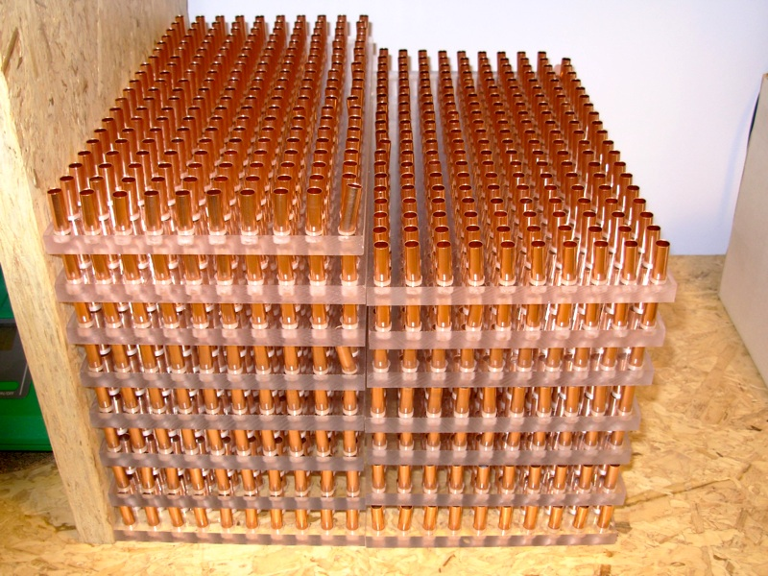
Q. How important is the copper jacket to the quality of the finished bullet, and where do the jackets come from? Further, how do you know if the jackets are of sufficient quality for use in benchrest?

A. The jackets are the main part of the bullet as far as making a bullet with excellent concentricity. As stated above the only Benchrest grade of jackets on the market are the J4 jacket (owned by Berger Bullets LLC). Their process of stamping out cups and extruding them into jackets has proven to excellent. What the users are looking for is a very uniform jacket wall thickness. This wall thickness is measured with tubing micrometers to the range of .0001”. Anything jacket that show excessive variation in wall thickness will not produce a bullet of the quality that is required for the BR game.

The other measurable check is weight. Good control of the original sheet metal thickness aids in the consistent weight and thickness of the finished jacket. To date I have not had any lots of jackets that were outside of acceptable tolerances.

Q. The core of the bullet is lead; to what extent do you go to make sure the core is of very high quality and uniform weight?

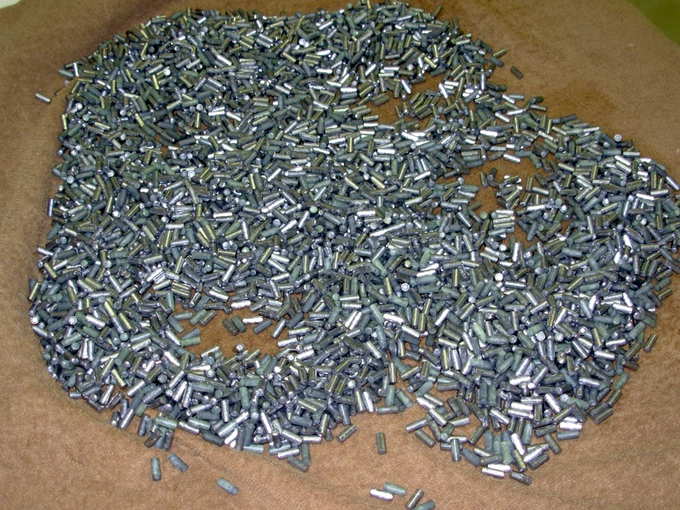
A. The makers of BR bullets typically use virgin lead, or a very small percent of antimony can be used. The individual bullet maker and their production process decide this. Most of the major bullet manufacturers have core-cutting machines to produce these cores. These cutters can be manual shears or automated. The cores are cut from lead wire stock off of a roll. The lead wire is straightened, lubed and fed into the cutter.

The weight of the core is adjusted to the desired target weight. This can be done by cutting to desired weight, or the cores can be made slightly over weight and then run through a squirt die to get to the desired weight. Once the cores are produced to the desired weights, the cores are cleaned of all oils or contaminants. This can be done with various types of solvent based cleaners, or boiling, or a combination of thereof. The goal is to get the cores clean enough that there will be reduced chance of a core separation from the jacket due to contamination.

Q. In seating the core into the jacket, what operations can be done to help improve the quality of the final product?

A. You need to start with a clean jacket. Cleaning of the jackets will remove any traces of oils from the production process. Then a re-lubing of the outside of the jackets must occur. As there is a tremendous amount of pressure used in seating the core, it is critical to get just enough lube evenly distributed on the outside of the jacket to prevent wear on the dies and unwanted stretching of the jacket, or sticking the jacket in the die.

The cleaned cores are now dropped into the lubed jackets; again with every effort to keep any lube out of the interior of the jackets and outsides of the cores is a priority. The cores are of a lesser diameter then the interior of the jackets, and the jackets must be of a lesser diameter than the core-seating die that is used in the next step of the process.

The following steps are where the true quality of the BR bullet begins to be established.

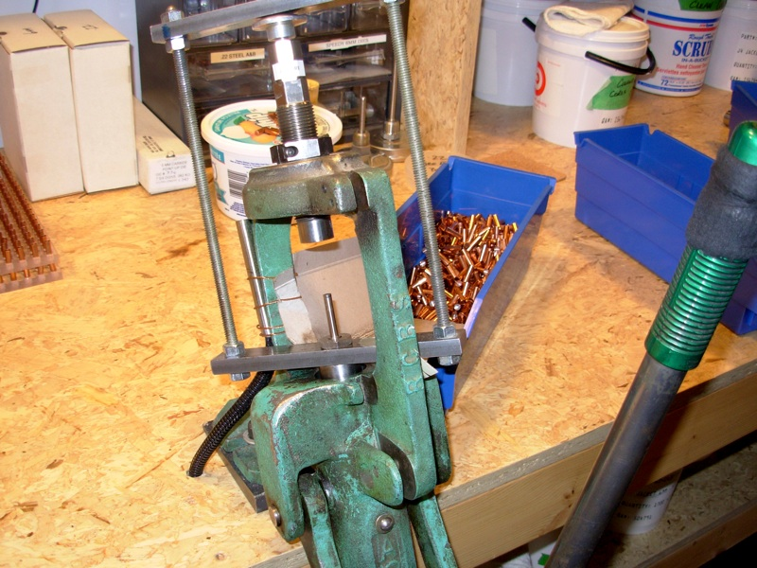
The core-seating die needs to be adjusted to just the right level to enable sufficient and consistent pressure to develop inside the die to fully seat the soft lead cores into the jackets. It is very important to have exactly the right diameter of core punch on hand to press the core into the jacket. The punch can’t scrape the inside walls of the jacket, or allow any excessive bleed by of the lead at what is called the lead line. This requires a good selection of different sized punches in .0002” increments. The core seating operation must produce the proper expansion of the jacket into the die and the proper expansion of the lead against the jacket walls. This takes tremendous pressure and, if done correctly, will actually swell the die. The die will return to normal size on the return stroke and actually grab the jacket and core and pull it off the punch. At the end of the return stroke a knockout punch will eject the jacket from the die.

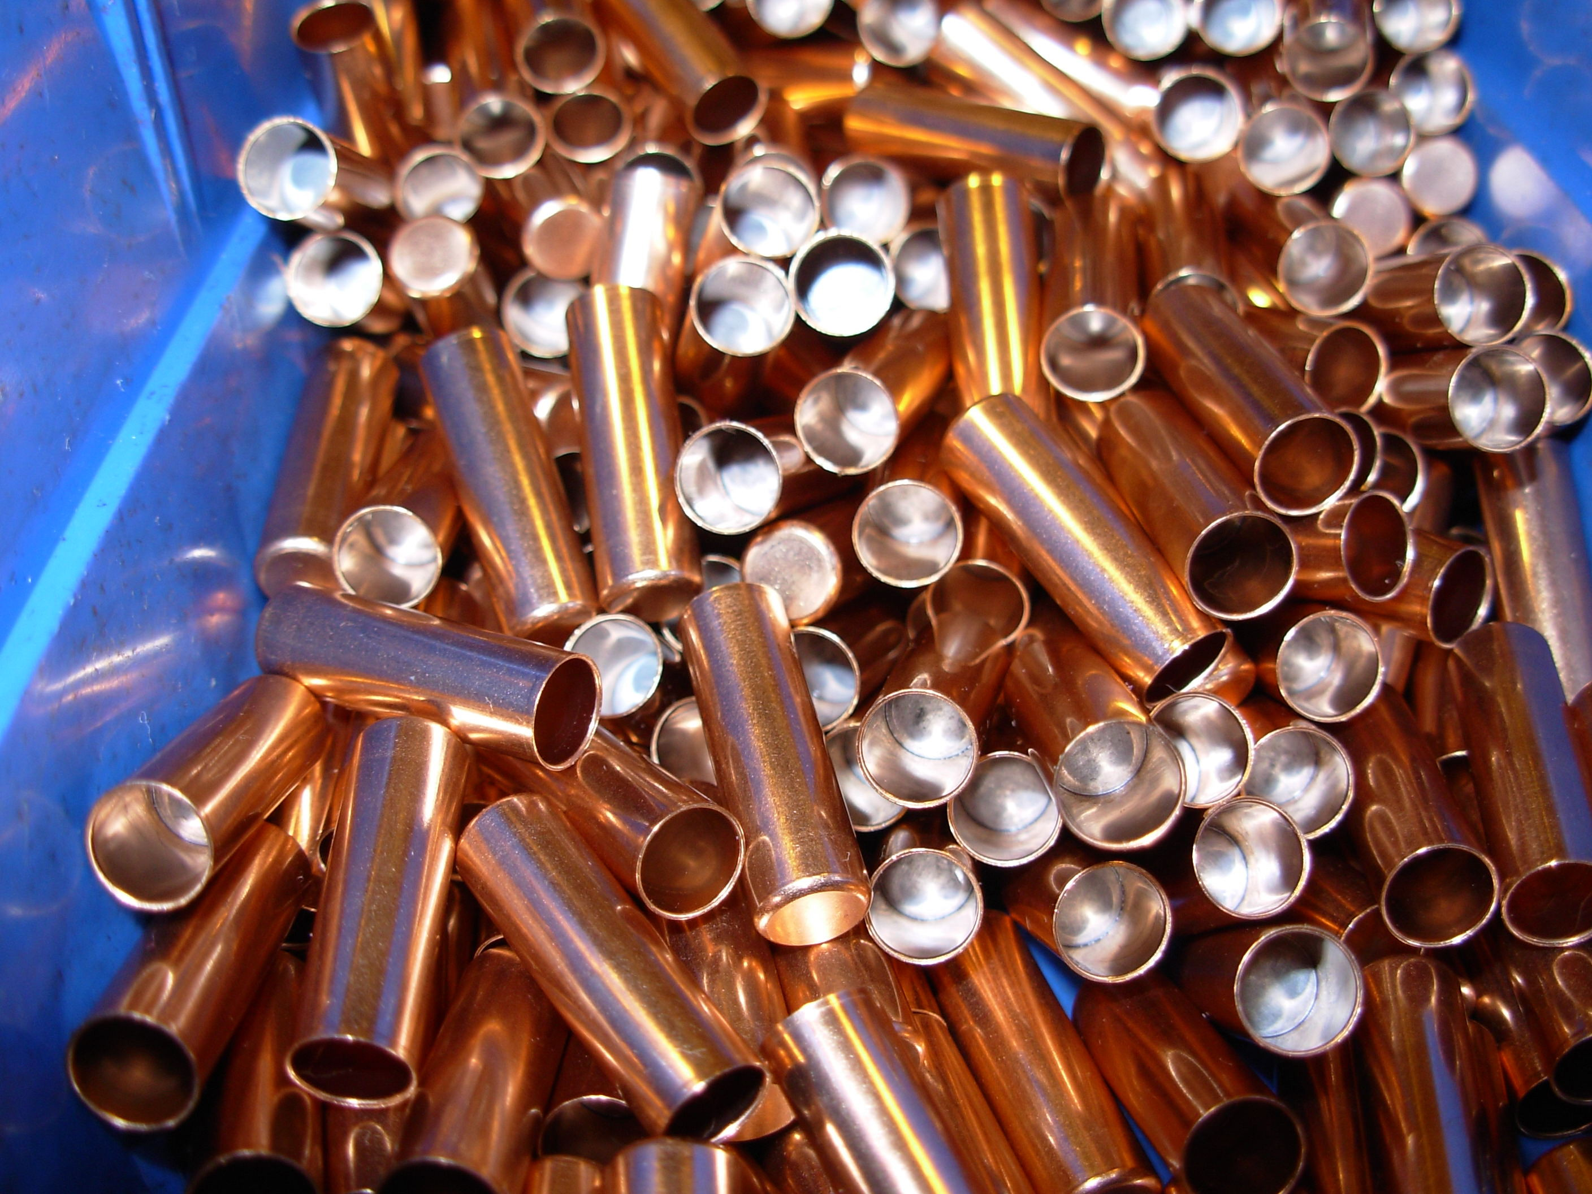
From a quality standpoint this is where the bullet maker can use “feel” as an aid to producing benchrest quality bullets. Because each stroke of the press handle must be as consistent and repeatable as possible, the operator gets to do a type of quality control check with each pull of the press handle. As an example, an undersize core will be felt in the handle as it will take less effort to seat the core. This underweight or under expanded core and jacket, can then be rejected. That is in simple terms the true essence of the difference between custom hand swaged bullets vs. machine swaged bullets. Additional checks like weighing and measuring of the seated core and jacket further aid in maintaining the quality at this part of the process.
Q. The next step is the point up operation. This is where you form the pointy end of the bullet. What can be done to ensure uniformity at this stage? What does the quality of the point up die have to do with the outcome?

A. Several things take place at this stage that can determine the final quality of the bullet. For example; it is a common practice to allow 24 hours between the core seating operation and the point up operation. This will allow the materials to normalize or stabilize before working the materials again. Of course cleanliness must be maintained so as not contaminate the die, and lubing of the jacket may or may not be done again.

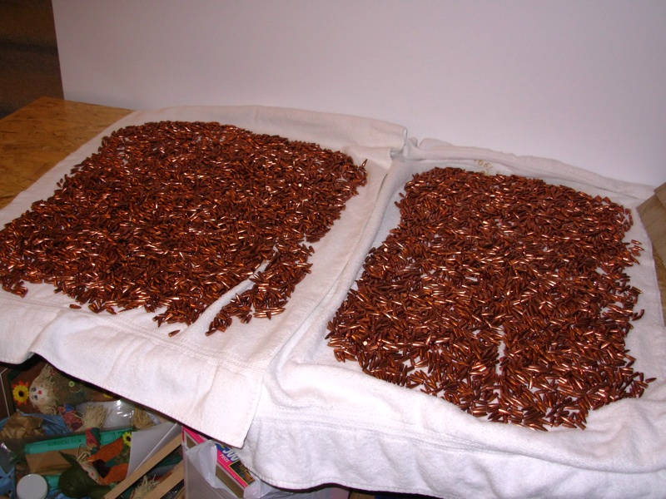
The final shape and final quality of the bullet is controlled by the point up die. Here we rely on the manufacturer of the point up die to deliver the degree of quality we are seeking. The die will have to have an indicated runout that can only be measured in the tens of thousands of an inch and it needs to be scratch free. Point up dies will often be of carbide to promote longevity of the die.

Using the jackets with the cores already seated in place, we are ready to proceed. It is important to note that the point up die the point up die must collapse the straight walls of the jacket into a point without causing any deformation like wrinkles, splits or eccentricities. There is a knockout punch at the top of the die that uses a pin extending through the hollow point to push the fully formed bullet out of the die. The diameter of the knockout pin determines the size of the hollow point of the bullet being made. A very small hollow point will require a very narrow pin. Some compromises will be made here, as too narrow of a pin will just get stuck in the lead core as it goes to push the fully formed bullet out of the die, and too wide of a knockout pin means a wider hollow point

Uniform use of the press handle will ensure the overall length (OAL) of the bullet is consistent. This OAL is measured from the base of the bullet to the ogive, and is measured to the thousands of an inch. This is the final step in insuring a benchrest quality bullet is produced.

Lastly the bullets are cleaned of any residual lube left on the outside of the bullet and packaged for shipping.

To close this article, you can see that there are many quality control checks on every single bullet on every single stage of the manufacturing process. This is what separates the mass produced bullet from the benchrest bullet. When you see the amount of labour that goes into producing benchrest bullets it is easy to see where the cost comes from, but also where the quality comes from. There really is no other choice for people involved in competition BR.
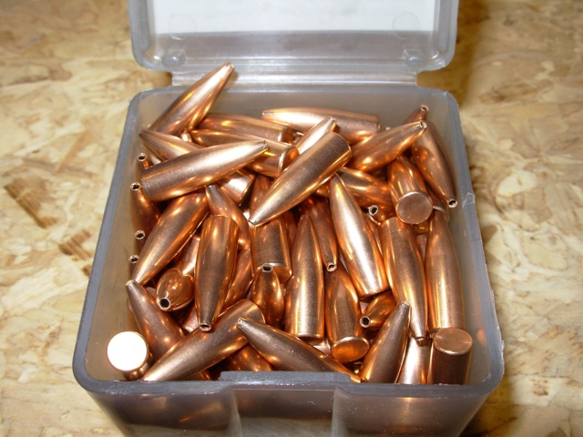
Thanks to Dan for taking the time to answer my questions. You can reach Dan at opel@telus.net to answer any questions you may have.

-Rick Pollock

