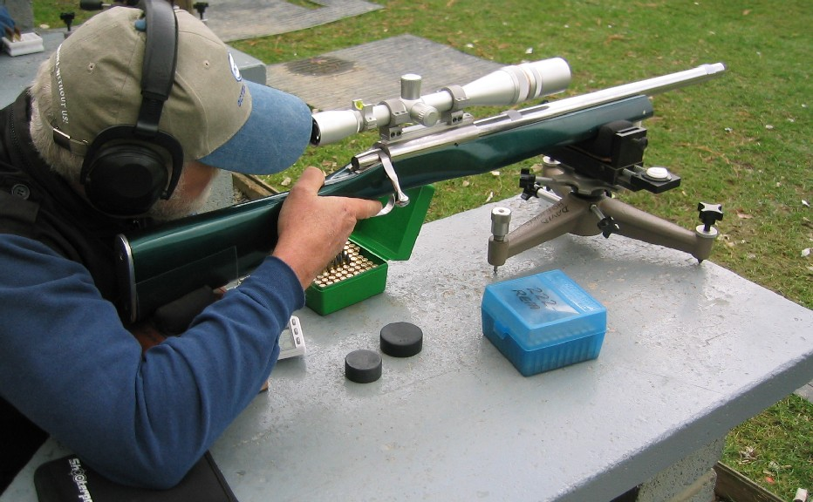

Fourth Annual Varmint for Score (VFS) Fraser Valley
Center Fire Benchrest Championship
Sunday July 3, 2016
Mission & District Rod & Gun Club
10969 Dewdney Trunk Rd.
Mission, BC, V2V 4J3
Clubhouse Telephone: 604-826-6515 For directions see the Website. http://www.missionrodandgun.com/

Match contact Joe Mendham: See below.
--------------------------------------------------------------------------
Registration Form
I do hereby release the Mission Rod and Gun Club along with their officers and officials from any and all claims for liability and damage that may be sustained by me by virtue of my participation in this match, conducted by said club.
Signed_________________________________ Date__________
Printed Name______________________________
Address_________________________________________________________________________
City_____________________________Province/State______________Area Code/Zip___________
Email Address___________________________________ Phone number______________________
What Club are you a member of? ______________________________Membership #____________

Two Classes: Benchrest rifle, Factory Rifle, The organizers reserve the right to determine rifle class.
Please complete as much detail as is known below.
Class _________________Cartridge/Cal.___________ Action__________________
Barrel Mfg____________________ Stock Mfg_______________
Stocker______________ Gunsmith___________________ Scope___________ Power_____X
Bullet Maker____________________ Weight _______ Powder._________ Weight _________

Match Fee $40. Please bring cash with you to the range. Payment signature __________

Course of fire: 20 score rounds using Hunter targets at each of 100, 200, and 300 yards (60 score rounds total)
Scoring: 11 point per bull’s-eye system- (X dot counts as 11)
Schedule: 8:00 Registration and set up
9:00 AM. Matches begin
Lunch in the Clubhouse (provided)
Scoring, Coffee, and Prizes in the Clubhouse following the Match
Expected finish time before 4 PM

Please Register by May 30, 2016. Mail to: Joe Mendham, #305-1275 W15th Ave.,Vancouver B.C.
V6H 1R9 Or Email: joemendham@hotmail.com .
For more information please E-mail, text or phone my Mobile 1-604-220-2059.

