2009 Alberta Provincials – September 5,6,7

Once again the finest BR shooters in Western Canada gathered at the Rosebud Silhouette & Benchrest Club just west of Calgary to contest the Alberta Provincials. We had the pleasure of several out of towners joining us. Calvin Yanchiki came in from Winnipeg, and we had Joe Mendham and Lowell Boyd, both of Vancouver making the trek.

This was a BRSC sanctioned group shoot with LV, HV and Unlimited (10-shot) rifles eligible. Practice began on the Friday with most of the field in attendance.

Saturday we shot the LV and HV 100 yards. Conditions were not too bad with the LV won by Paul Ross with a .2186 agg and the HV won by Rob Seeman with a .2212 agg.

Sunday the Unlimited (10-shot) was contested at both yardages with the 100 yd won by Tony Gauthier with a .2778 agg and the 200 yd was won by Rob Seeman with a .3791 agg.

Monday proved to be a difficult day for most shooters as the wind really picked up. The true wind shooters rose to the top and we saw Dan Opel win the 200yd LV with a .3454 agg and Rob Seeman win the 200yd HV with a .3112 agg.

Grand Agg Winners as follows:
LV Grand - Dan Opel .3454
HV Grand – Rob Seeman .2662
Unl Grand – Rob Seeman .3644

2-Gun Winners as follows:
1st – Rob Seeman .3328
2nd – Dan Opel .3380
3rd – Joe Mendham .3414

3-Gun Winners as follows:
1st Rob Seeman .3433
2nd Tony Gauthier .3657
3rd Joe Mendham.3755

These aggs proved once again how tough the Rosebud range can be when the winds get up. Mother Nature is unforgiving, and continued to severely punish anyone who missed a letup or push. Lyle Turton knows this well as he received the trophy for the largest group of the weekend! Lyle is a strong competitor and we appreciate his good nature in receiving this trophy. It happens to everyone Lyle!
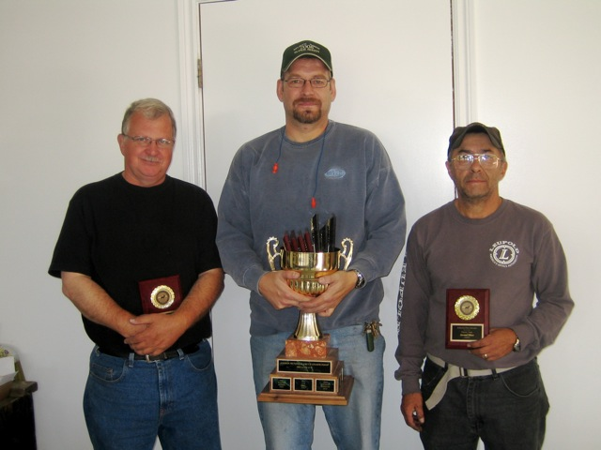

Above photo captures the 3-Gun Winners with (L-R) Joe Mendham – 3rd, Rob Seeman – 1st, and Tony Gauthier – 2nd.

The BRSC would like to thank the sponsors of this event for their generous support:

Leupold Canada – Korth Agencies – Leupold Scope
Hirsch Precision – Peter Dobson – Lapua brass
Plenty O’ Patches – Doug and Maxine Seib – Cleaning Accessories
Opel Bullets – Dan Opel – Bullets
Henry Rempel – Barrel Chambering
Paul Ross – Cleaning Cradle, Machinist Chest

That wraps up the 2009 season in BRSC; I hope to see everyone out in 2010. Check benchrest.ca for updates to the schedule as they become available.

-Rick Pollock

